Authorisation of Taxi Invoices

Document No.: | FI002-W08 v1.0
Author: | Glen Merritt
Issue Date: | 29 MAY 2026
Effective Date: | 12 JUN 2026

Foreword

The Academic & Clinical Central Office for Research & Development (ACCORD) is a joint office comprising clinical research management staff from NHS Lothian (NHSL) and the University of Edinburgh (UoE).

This work instruction will be followed by the R&D Finance Assistant to record and obtain authorisation for taxi invoices, ensuring that the supplier is paid within the agreed terms of payment and research teams enter the required information onto the EDGE system.

Instructions

Receiving Invoices

The Taxi Company (e.g. Central Radio Taxis) will send all R&D taxi invoices to loth.researchinvoicing@nhs.scot e-mail inbox.

Record all taxi invoices on the worksheet “Invoices” contained in the workbook Taxi invoice Register on the R&D shared drive; Research & Development\Finance\TAXI invoices\Taxi Invoice Register.xlsx.

Calculate the discount applied to each journey for the authoriser of the invoice. They will convert the invoice from pdf to excel using copilot and the discount is applied pro-rata.

Records the discounted journeys from the invoice into the “Job No” worksheet within the workbook Taxi invoice Register – see example below;

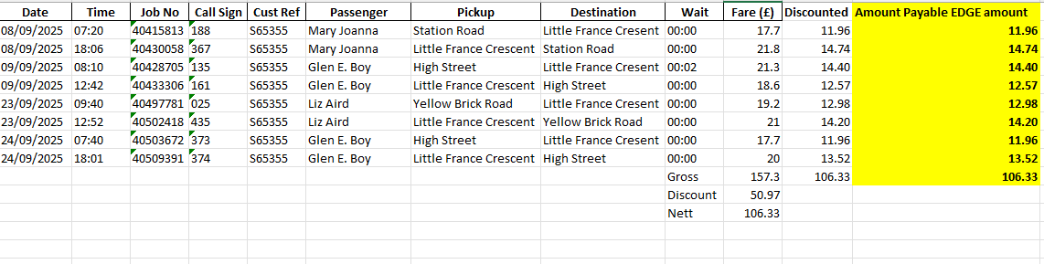

Send an email to the authoriser with the following attachments/details contained in the email:
- Pdf invoice [attachment]
- Discounted table of journeys (where discount has been applied to invoice) for research team to use data to input into EDGE [within email]
- Template containing and completed by R&D Finance Assistant showing the supplier, invoice number, cost centre, account code and invoice amount to be paid [within the email] – example given below;
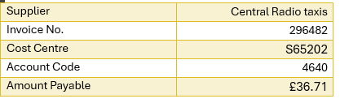
- Instructions for the authoriser [within the email]

The details of who can authorise the taxi invoice is found on the Taxi Authorisation List on the R&D shared drive; Research & Development\TAXI ACCOUNTS\Taxi Authorisation List DY 25 Apr 2013.xls.

Update the Taxi invoice Register with date of email and recipient of email for authorisation on the R&D shared drive; Research & Development\Finance\TAXI invoices\Taxi Invoice Register.xlsx.

References

- SOP FI002 Commercial and Non-Commercial Research Study Activity Recording, Invoicing & Tracking

